MUHAMAD AFIQ BIN ABDUL AZIZ NETWORK PROGRAMMING ITT440

2015180183

CS251 3A SOCKET I.O (PERL)

This program do add calculation. The client (client.pl)sent number to server(server.pl), server will reply total number.

To sent number, client must fill “end” after add number to submit to server.

Server.pl

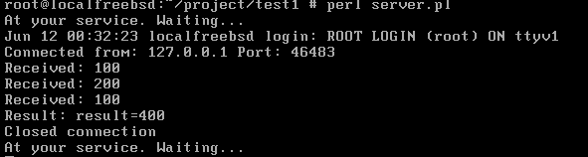

Client.pl

